Chapter 1 Activities Worksheet (32)
Activity 1-1 Installing Windows 7
Step 1 Your computers are already set up to boot from the DVD.
Skip steps 10 and 11.
Step 14 the value you will enter is 50000.
Step 19 x is your drive number.
Step 26 and 28 will not appear.
After step 28 Restart your computer.
Do not do step 30, do the steps below to install the drivers for the ASUS motherboard.
- Place the ASUS driver disk in the CD/DVD drive, wait for the AutoPlay window to appear.
- In the AutoPlay window, click on Run ASSETUP.exe.
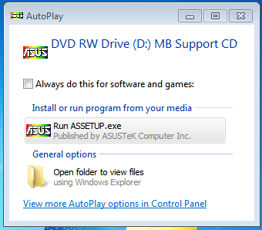
- In the UAC window click Yes.
- Click on Drivers button in the Menu at the top.
- Click on ASUS InstAll button.
- In the InstAll window select Install the drivers only.
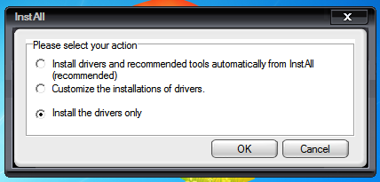
- Click OK.
- In Number of Reboots click OK. The Install will run, be patient and wait for all of the drivers to install. You will have to use your password on each reboot. If you hover over the progress bar you can see the progress of the driver installation.
- When you see “The installation is Complete. Please restart your computer” click OK, your computer will restart.
- Remove the ASUS driver disk for the CD/DVD drive and return it.
- Shut down your computer.
Activity 1- 2: Limited Permissions for Users Worksheet (16 points)
1. Step 7: While moving the slider fill in the table below.
Position | Notification | Recommendation
Top Position
First Position from Top
Second position from top
Bottom Position

Activity 1- 3: Fast User Switching
2. After step 7 using the snipping tool create a new rectangular snip showing the current user accounts on your computer and paste it below. (4 points)

Activity 1-4: Switching between Applications
Complete activity

Activity 1- 5: Working with Task Manager
Log on as UserX (where X is your drive number)
3. After step 6 using the snipping tool create a new rectangular snip showing the Task Manager dialog box and paste it below. (4 points)

4. After step 13 using the snipping tool create a new rectangular snip showing the Task Manager Processes tab and paste it below. (4 points)

5. After step 27 using the snipping tool create a new rectangular snip showing the Task Manager Processes tab and paste it below. (4 points)

